Names of Salvation
Yah & Yahoshua: Revealing the Names of the Most High and His Son
By Obadiyah Ysrayl

Click here to access this work with narration on our website

What's the name of the Heavenly Father and our Messiyah?

This very simple yet controversial question is asked of us in the book of Proverbs.

Proverbs 30:4 - Who hath ascended up into heaven, or descended? Who hath gathered the wind in his fists? Who hath bound the waters in a garment? Who hath established all the ends of the earth? What is his name, and what is his son's name, if thou canst tell?

Before delving into understanding and identifying the modern day Israylites, we must first bring some foundational but powerful biblical truths to the forefront. As you read on you'll soon discover that the children of Israyl were given the responsibility of bringing salvation to mankind. In fact, they are His earthly priests.

John 4:22 - Ye worship ye know not what: we know what we worship: for salvation is of the Israylites.

Exodus 19:5 - Now therefore, if ye will obey my voice indeed, and keep my covenant, then ye shall be a peculiar treasure unto me above all people: for all the earth is mine:

v. 6 - And ye shall be unto me a kingdom of priests, and an holy nation. These are the words which thou shalt speak unto the children of Israyl.

The Most High gave the Israylites the duty of bringing the praises of His name back into the earth. Satan and his followers have tried for thousands of years to remove the Father's name from the remembrance of men. Halleluyah, he has failed!

When most people are asked about the name of the Heavenly Father, you'll get different answers—God, Jesus, Allah, Jehovah, etc.

Some may even claim that it doesn't matter what you call Him. However, the truth is none of these answers can be validated from the bible. The Most High has ONE name. His name is above all names. Within His name lies His power and main attribute.

What's in a Name?
Names are given as reference for identification. Every human born into existence is given a name. They are given based on how good or bad they sound when spoken in some cultures. In other cultures, they are given to associate that person with his god(s), heritage, history, and country. In many cultures, especially with the ancient Hebrews, names were given based on the character of the person.

Abraham's Name Change
For example, Abraham was a prophet of the Most High, but he was not initially called by Abraham. He was born Abram. Yet his name was changed by the Most High to fit his new character or role as a father of many nations.

Genesis 17:1 - And when Abram was ninety years old and nine, the Almighty appeared to Abram, and said unto him, I am the Almighty power; walk before me, and be thou perfect.

v. 2 - And I will make my covenant between me and thee, and will multiple thee exceedingly.

v. 3 - And Abram fell on his face: and the Master talked with him, saying,

v. 4 - As for me, behold, my covenant is with thee, and thou shalt be a father of many nations.

v. 5 - Neither shall thy name any more be called Abram, but thy name shall be Abraham; for a father of many nations have I made thee.

Abraham (or Ibraham in Hebrew) literally translates into “The father of a multitude.”

Joshua's Name Change
The Israylite general, Joshua's (or Yahoshua in Hebrew) name was changed by Moses when he was given charge over the children of Israyl after the death of Moses.

Numbers 13:16 - These are the names of the men which Moses sent to spy out the land. And Moses called Oshea, the son of Nun, Yahoshua (Joshua in English).

The name, Joshua or Yahoshua, means, "Salvation of Yah." The spirit of the Most High dwelt upon Joshua, and he helped bring salvation or victory to the children of Israyl during the conquest of Canaan.
Who is Yah?
According to the bible, Yah is the name of the Most High. It's revealed in the book of Psalms.

Psalms 68:4 - Sing unto the Almighty, sing praises to His name: extol Him that rideth upon the heavens by His name YAH, and rejoice before Him.

Notice the name, JAH, listed in the standard King James Version (KJV). That is incorrect. There is no letter J, J equivalent, or J sound in the Hebrew, Latin or Greek languages. In fact the letter J is one of the newest letters in the English alphabet. It came into usage sometime after 1630. This means that 2000 years ago there was not a person on earth named Jesus nor was there a people called Jews or a city named Jerusalem. The names Jesus and Jehovah are not in the 1611 King James Bible. Even King James' name was spelt differently back then. It was Iames.

Let’s get greater understanding of Yah’s name.

His name is not limited to one language. It can be spoken in every tongue on earth. The meaning of Yah is “The self-existing one or to self-exist.” Yah, the Almighty Power, is the only entity in all creation that exists from His own power. Everything in creation exists from the power of Yah. This includes Angels, both fallen and righteous, man, animals, planets, stars, moons, suns, etc. But He alone is self-existing. That is a power too profound for human understanding.

Yah can be found in many of the ancient prophets' names, such as:

- ObadiYah, which means, "Servant of Yah"
- ZechariYah - "Yah remembers"
- IsaiYah - "Yah is salvation"
- ZephaniYah - "Yah hides"

The phrase, HalleluYah, means "Praise You Yah."
The King James Version (KJV) Conspiracy
The spelling of those names are different in the KJV. Notice that Isaiah does not have "Yah" spelled in its ending although it is pronounced alike.

The same can be said for Obadiah, Zechariah, Jeremiah, etc. This illustrates how deep the conspiracy has stooped to remove Yah’s name.

The Proof of Yah is in Our Roots
During the time of American slavery our people would sing beautiful songs that were entitled “Negro Spirituals” (more on the spirituals and the story they told are addressed in later chapters). One popular song that is proof of Yah's name is the spiritual, “KUMBAYAH,” which means, "Come by Yah." Our ancestors were calling upon the Most High, Yah, to come and save them. They knew His name was Yah.

According to The Transatlantic Slave Trade Database website, slavevoyages.org, hundreds of slaves had Hebrew names containing the name of Yah.

The Transatlantic Slave Trade Database
Slave Names with "Yah" in Them

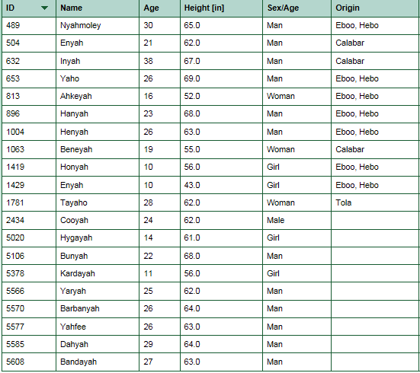
What it Means to Take His Name in Vain
According to dictionary.com the word vain means: without real significance, value, or importance; baseless or worthless: vain pageantry; vain display. Yah has commanded us not to make His name worthless, without any real significance or importance in the scripture that follows.

Exodus 20:7 - Thou shalt not take the name of Yah in vain; for Yah will not hold him guiltless that taketh His name in vain.

How do you take his name in vain?

By replacing it with the name of gods, devils, and demons whose names are lesser than the Self-Existing One. Neither Jesus, Allah, Jehovah nor Buddha equates. And if you are calling the Most High by any of those names you have made His name baseless and worthless—ultimately taking it in vain.

The Pagan Titles, Lord & God
Notice the same scripture you just read that admonishes us not to take Yah’s name in vain substitutes two titles, Lord and God, for our Father's name in the KJV (Exodus 20:7). Both Lord and God are titles and neither is a name. The book of Psalms has given us the name of the most high as Yah (Psalms 68:4).

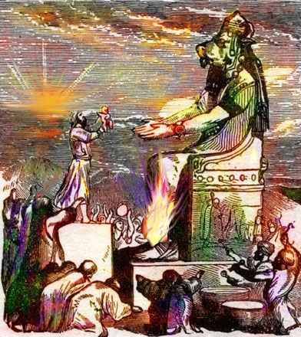
The Origin of Lord
The god Baal or "Lord"
The title, LORD, can be traced back to the ancient Canaanite god, Baal (bu-ald).

Baal is a Canaanite-Phoenician word that means, "Lord." There were many baals or lords of different names in the ancient times. Baal was worshipped in high places like a pagan temple or altar that was built on a high mountain or hill, because the people felt they could get closer to the gods if their places of worship were located on high plains. The higher the hill or mountain, the closer the believer is to his god. Baal worship was done with child sacrifices and money. People brought taxes to this pagan deity. Baal-gad which is translated into English as Lord God means, "Lord of Fortune" or "Lord of Money." So when you refer to Yah as "Lord," you are in fact calling Him, "Baal."

Ironically, Yah warns about this in the following scripture:

Jeremiah (JeremiYah) 23:26 - How long shall this be in the heart of the prophets that prophesy lies? Yea, they are prophets of the deceits of their own heart;

v. 27 - Which think to cause my people to forget my name by the dreams which they tell every man to his neighbor, as their fathers have forgotten my name for Baal (lord).

"Their fathers have forgotten my name for Baal..."
The Canaanite God, Baal or Lord

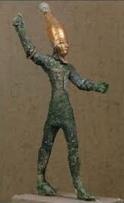 | 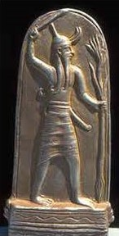 | 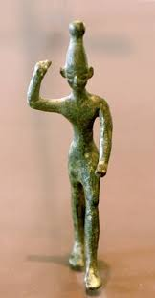
The Origin of God
All religions worship a god or gods. The only thing that will separate your god from the next is his or her name. Over the years a very noticeable thing has been developing amongst African-American Christian Churches. The Nation of Islam leader, Louis Farrakhan (pictured right), has been traveling to the churches making speeches containing many references to God.

On the surface the Christians and Muslims are supposed to worship different gods. Islam calls their supreme deity by the title, Allah, or god, and so do the Christians. If a Muslim minister can stand before a Christian Congregation and say, "God is Great!" and the entire place erupts with applause then is there really a difference?
Louis Farrakhan
Nation of Islam Leader

Many bible dictionaries and concordances will tell you that wherever Lord and God is written in the scripture that the name should be Yah.

God - Our word god goes back via Germanic to Indo-European, in which a corresponding ancestor form meant “invoked one.” The word’s only surviving non-Germanic relative is Sanskrit hu, invoke the gods, a form which appears in the Rig Veda, most ancient of Hindu scriptures: puru-hutas, “much invoked,” epithet of the rain-and-thunder god, Indra.
(From READER’S DIGEST, Family Word Finder, page 351) (Originally published by The Reader’s Digest Association, Inc., Pleasantville New York, Montreal; Copyright (C) 1975)

God means "invoked one." Satan and demons can be invoked.

The Meaning Elohim & El | EL vs. YL
The Hebrew word Elohim means "gods." In ancient times, the gods were the fallen angels. And the supreme God was the chief fallen angel, Satan. He was known to the people by many different names and titles. The Hebrew word El, the singular form of "god," is also the name of a Canaanite god. In fact, El and Baal were chief deities of the ancient Canaanites and other nations. You may have noticed that we don’t spell the name Israyl with the letters E and L at the end. We spell it with Y and L. Again, EL is a god. On the other hand, YL means "power." The name Israyl means "to strive, overcome, and rule with YL (Power)."

Yah is not a god
Yah is separate from the gods. In fact, scripture says He judges them.

Psalms 82:1 - Yah standeth in the congregation of the mighty; he judgeth among the gods.

Yah, the Almighty, was never included with the gods or god. Satan is a god.

2 Corinthians 4:4 - In whom the god of this world hath blinded the minds of them which believe not, lest the light of the glorious good news of Messiyah, who is the image of Yah, should shine unto them.

Yah was always known as the Creator, The Power Almighty, The Heavenly Father, The Most High, and The Set Apart One. His name is above any title. He gave us the knowledge of His name to reverence it; not substitute or change it. The Messiyah made it a point to let us know that he taught his brothers the true name of the Most High.
John 17:6 - I have manifested thy name unto the men which thou gavest me out of the world: thine they were, and thou gavest them me: and they have kept thy word.

v. 12 - While I was with them in the world, I kept them in thy name: those that thou gavest me I have kept, and none of them is lost, but the son of perdition; that the scripture might be fulfilled.

v. 26 - And I have declared unto them thy name, and will declare it: that the love wherewith thou hast loved me may be in them, and I in them.

The Messiyah taught the name of Yah. He did not teach in any title. The titles, Lord and God, in the KJV is an intentional substitution of His name to deceive the masses and hide the true name of the Most High. And many of the newer bibles such as “The Scriptures” by the Institute for Scripture Research have corrected that by replacing lord and god with the proper names and titles.

The Name of Our Messiyah is not Jesus
Originally written in Hebrew, the bible was later translated to roughly every language on the planet. As we mentioned earlier, there is no letter J in the Hebrew, Greek or Latin tongue. Therefore there could not have been a person in existence among the Israylites 2,000 years ago named Jesus.
Born through the womb of an Israylite woman, the Messiyah lived as an Israylite man amongst Israylites, bearing an Israylite name. Names carry meanings in Israylite culture. The Messiyah's name reflected his mission as our savior. We're informed about this in the scriptures—particularly in Matthew.

Matthew 1:21 - And she shall bring forth a son, and thou shalt call his name Yahoshua: for he shall save his people from their sins.

His True Name is Required for Salvation
The Messiyah's name, Yahoshua, means "the salvation of Yah" or "Yah’s salvation." He carried the name of the Father in his name, like the majority of Israylites in those days. Yahoshua has been granted the power from Yah to deliver His people, the Israylites, from their sins first and then the whole of mankind. His name is above all names given to men and it is required for salvation.

Acts 4:12 - Neither is there salvation in any other: for there is none other name under heaven given among men, whereby we must be saved.

His name is so important that our very salvation is based on us knowing the truth of his name. A true belief in Yahoshua as Messiyah can lead to eternal life in the kingdom. While many have committed John 3:16 to memory, many fail to read the two proceeding verses to gain understanding of what our belief in Messiyah is based on.

John 3:16 - For Yah so loved the world, that He gave His only begotten Son, that whosoever believeth in him should not perish, but have everlasting life.

v. 17 - For Yah sent not his Son into the world to condemn the world: but that the world through him might be saved.

v. 18 - He that believeth on him is not condemned: but he that believeth not is condemned already, because he hath not believed in the name of the only begotten Son of Yah.
According to scripture, those condemned are so because they did not believe in the true name of the Messiyah. Your salvation is based on his name which is not Jesus. The reason we are to believe in his name is simple. Yahoshua's name, just as Yah’s name, describes his characteristics. Everything about him can be found in his name. He is salvation.

1 John 3:23 - And this is his commandment, That we should believe on the name of his Son Yahoshua the Messiyah, and love one another, as he gave us commandment.

John 1:12 - But as many as received him, to them gave he power to become the sons of Yah, even to them that believe on his name.

Lamentations 3:26 - It is good that a man should both hope and quietly wait for the salvation of Yah.

Luke 3:6 - And all flesh shall see the salvation of Yah.

Yahoshua is not only found in the so-called New Testament, but from the beginning of the book to the end. Wherever you read about salvation, this is speaking of Yahoshua.
A Closer Look at Who Jesus Is & His Ties to Mythology
The name Jesus, like Jehovah, has no meaning. Before the letter J was added to Jesus some 380 years ago, the name, Iesus was rendered in the original 1611 King James Version (KJV) of the bible. This name is derived from Ieous,
the Greek goddess of healing.

Jesus is also related to the Greek God, Zeus. The Spanish language is derived from ancient Latin, hence why Spanish speaking natives are called Latinos. Interestingly, the Spanish pronunciation of Jesus is "HEY-ZEUS."

Jesus is not the English equivalent or translation of Yahoshua.

Jesus has no connection to Yahoshua. None of the apostles ever taught in the name of Jesus or Iesus. They taught in the name that our Messiyah was given from on high, Yahoshua.
Ieous
The Greek Goddess of Healing

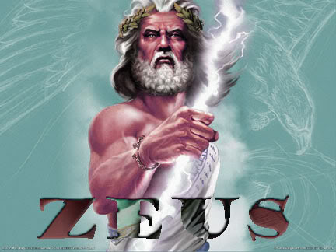
In the book of Acts the apostle Shaul / Paul recounts his first encounter with Yahoshua the Messiyah.

Act 26:13 - At midday, O king, I saw in the way a light from heaven, above the brightness of the sun, shining round about me and them which journeyed with me.

v. 14 - And when we were all fallen to the earth, I heard a voice speaking unto me, and saying in the Hebrew tongue, Shaul, Shaul, why persecutest thou me? it is hard for thee to kick against the pricks.

v. 15 - And I said, Who art thou, Master? And he said, I am Yahoshua whom thou persecutest.

Shaul / Paul made it clear that the voice that spoke to him spoke in the Hebrew tongue. And this voice introduced himself to Shaul as Yahoshua. He didn’t say Jesus because at the time of this conversation the name Jesus was not in existence. All the letters of Paul, Peter, James, etc., called the Messiyah by the name of Yahoshua. This is the only name they knew. This is the name of salvation.

Not one verse has ever stated that the Most High does not care what you call Him. He has made it a commandment for you not to take His name in vain. The Messiyah's name is above all EARTHLY names. Only one has been sent to be salvation itself.

You will be held accountable for calling on the Almighty and our salvation by false deities. Would you allow your family and friends to call you by another name?

Yah and Yahoshua are real...

About Obadiyah Ysrayl
Obadiyah Ysrayl is one of the founding members of Israylite Heritage (IH). Girded with the mission to fulfill his Yah ordained duty of restoring the truth of the bible to the Hebrew Israylites and all other nations since 1996, he is heavily involved in the community. Serving as a teacher for the IH family, Obadiyah presents weekly lessons via the Paltalk chat room, Yah and Yahoshua are Real, on Saturday, the true Sabbath, followed by a Q&A session every Thursday. On Sunday, he hosts the Israylite Way biweekly radio show on Blog Talk. Visit the Israylite Heritage website for his full schedule.
He lectures and conducts immersions worldwide.
Most known for the documentaries, The Curses of the Hebrew Israylites and The Bible vs. Christianity, along with the video lesson series, The Physical Appearance of Israyl, he is the driving force behind Israylite Heritage Productions and author of Restoring the Forgotten Heritage to the Forgotten People: The Identity and Destiny of the Children of Israyl. Mr. Ysrayl is the regent of the Israylite Heritage Research & Fellowship Center (IHRFC) in Chicago, IL, and the President and CEO of sister charity, Israylite Heritage Feed My People.

He welcomes you to connect with him on Facebook and join the IH mailing list to stay abreast of newly released productions and publications. Schedule a lecture with Obadiyah online or by calling 844.SEEK.YAH | (844)733-5924.

