**The Physical Appearance of**

**The Children of Israyl • Part 1**

**The World's Greatest Secret Exposed**

**By Obadiyah Ysrayl**

**Click**[**here**](http://www.israyliteheritage.com/the-physical-appearance-1)**to access this work with narration on our website**

**For years, scholars, theologians, and archaeologists have debated the answer to the question, "How did the ancient Israylites look physically?"  Although the scriptures and other historical documents have left a lot of evidence that confirms the physical appearance of the Israylites, much of this information is still unknown to the masses.**

**The popular belief today is the people known as "Ashkenazi Jews" are the *only* direct descendants of the ancient Israylites.   Can this be proven beyond a shadow of a doubt?**

**The Children of Israyl are key figures in the bible.  They’re mentioned over 2,500 times from the book of Genesis to Revelations.  The bible gives us detailed information about the Israylites' interaction with the Most High, Yah.  The scriptures were never intended to be a religious book.  It is history, instructions, and prophecy.  It is a book of life.**

**Let’s examine these facts that the scriptures give us about Israyl.**

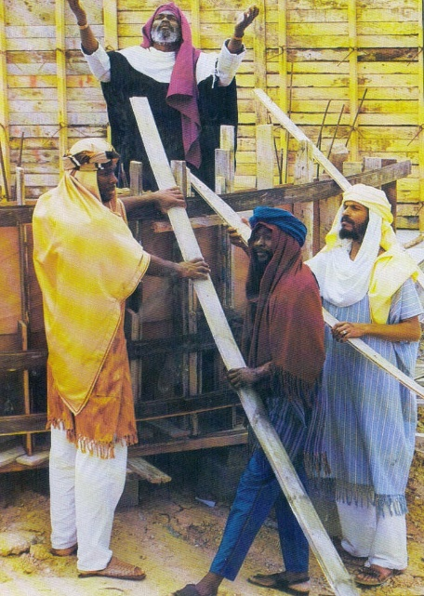**The Table of Nations**

**According to the bible, the children of Israyl are descendants of Abraham who was a descendant of Noah's son, Shem. When Yah flooded the world for the disobedience of mankind He saved a family of eight: Noah, along with his wife and three sons, and their wives.  Noah's sons, Shem, Ham, and Japheth repopulated the world after the great flood.**

**Genesis chapter 10 gives us a full breakdown of his sons' descendants and the nations they created.  While we will focus our attention on two—the children of Shem and Ham—let's first identify the descendants of Noah's youngest son, Japheth.**

**Genesis 10:1 - Now these are the generations of the sons of Noah, Shem, Ham, and Japheth: and unto them were sons born after the flood.**

**Sons of Japheth - The Europeans or Gentiles**

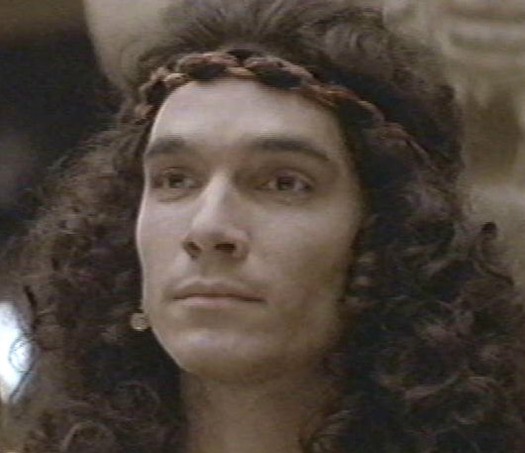**This chapter tells us that Japheth is the father of the European nations or Gentiles.  The word, *Gentiles*, comes from the Hebrew word, *Goy*, which means, "nation."  Its plural form is *Goyim*, and this title was applied to the people who lived north of the Children of Israyl.  The Hebrews knew there were people north of them in Europe, but they did *not* know these people by their nationality.  They were *not* familiar with their nations.  So we called them "the nations" or Goyim (Gentiles).**

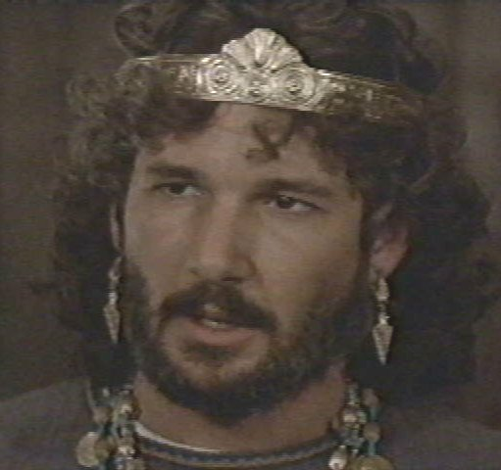**Notice in scripture that the nations surrounding the children of Israyl were called by their nationality such as The Egyptians, Babylonians, Canaanites, Edomites, Hittites, etc.  We did *not* get familiar with who the Gentiles were until the time of the Greek invasion during the days of Alexander, King of Macedonia, also known as Alexander the Great.  Fourteen nations descended from Japheth.**

**Genesis 10:2 - The sons of Japheth; Gomer, and Magog, and Madai, and Javan, and Tubal, and Meshech, and Tiras.**

**v. 3 - And the sons of Gomer; Ashkenas, and Riphath, and Togarmah.**

**v. 4 - And the sons of Javan; Elishah, and Tarshish, Kittim, and Dodanim.**

**v. 5 - By these were the isles of the Gentiles divided in their lands; every one after his tongue, after their families, in their nations.**

**Seven Sons of Japheth**

**1. Gomer: Celts, Germans**

**2. Magog: Scythians, Slavs, Russians, Bulgarians, Bohemians, Poles, Slovaks, Croatians**

**3. Madai: Indians & Iranic—Medes, Persians, Afghans, Kurds**

**4. Javan: Greeks, Romans, French, Italians, Spanish, Portuguese**

**5. Tubal: South of Black Sea**

**6. Meshech: Russians**

**7. Tiras: Thracians, Teutons, Scandinavians, Anglo-Saxons, Jutes**

**Map of Where the 7 Sons of Japheth Dwelt**

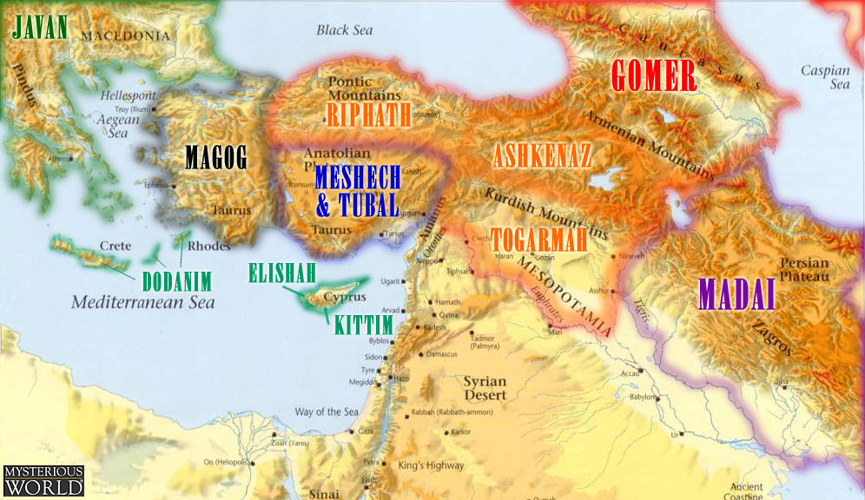

**Sons of Ham - The Africans**

**Ham gave birth to the African nations.  He had the most descendants of Noah's sons, populating Africa and other parts of the “mid-east.”  The word *Ham* in Hebrew is *Khwam*, and it means "hot, heat, and black."**

**Genesis 10:6 - And the sons of Ham; Cush, and Mizraim, and Phut, and Canaan.**

**Cush**

**The first born son of Ham, Cush, forms the Kushite nation.  They were also called and known as the ancient Ethiopians.  Ethiopia comes from the Greek word, *Aethipos*, which means, "burnt or black face."  The Greeks applied this name to the people living south of Egypt.**

**Wall Drawing in Egypt of the Kushites / Nubians / Egyptians**

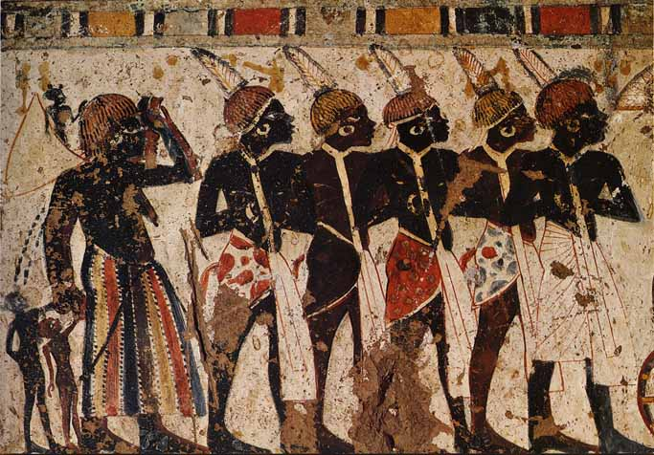

**Mizraim**

**Pronounced "MIZ-RA-YEEM," *Mizraim* is the Hebrew name for *Egypt*.  The Greeks called Mizraim, *Aegyptus (Aigyptos),* which they used in their literature.  Aegyptus is where the name Egypt comes from.  The Egyptians actually called themselves *Khemet / Kemet,*which is a variation of the Hebrew word *Khawm (Ham).*It means, “People of the black land.” Today its official name is Jumhuriyat Misr al-Arabiyah, which means the "Arab Republic of Egypt."  Egypt is referred to as the land of Ham in several biblical passages.**

|  |  |
| --- | --- |
| **Ancient Egyptians** | **King Tut** |

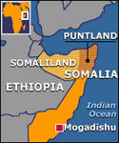**Phut**

**While scholars have identified ancient Phut as the Libyans, the ancient Egyptians identify them as Somalians.  Therefore, the ancient Somalians are the Phutites.**

**Images of Phutites**

**Taken from the Walls of Ancient Egypt**

|  |  |  |
| --- | --- | --- |
|  |  |  |

**Canaan**

**The Caananites are the original inhabitants of the land of Israyl.**

**Images of Ancient Canaanites**

|  |  |  |
| --- | --- | --- |
|  |  |  |

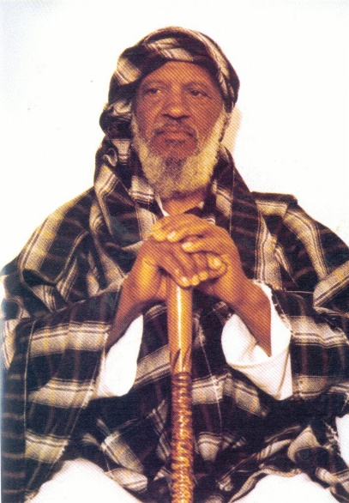**Sons of Shem - The Israylites**

**The Israylites are descendants of Noah's son, Shem, through the biblical Abraham.  Abraham gave birth to a son named Isaac, who gave birth to a son—Jacob.  Jacob had twelve sons who were the progenitors of the twelve tribes of Israyl.**

**Ancient Israyl was comprised of twelve tribal nations.  Each one of Jacob's sons became a tribe that made up the greater nation of Israyl.  For example, Reuben's descendants became known as the tribe of Reuben.  Judah's descendants became known as the tribe of Judah, and so on and so forth.  The children of Israyl are the descendants of Jacob whose name was changed to Israyl by the Most High.  This is why his descendants are called Israylites, which means "descendants of Israyl."  Remember, Israyl was not only the name of our land but also the name of our people through our father, Jacob (Israyl).**

**Genesis 32:28 - And he said, thy name shall be called no more Jacob, but Israyl: for as a prince hast thou power with Yah and with men, and hast prevailed.**

**The Genealogy of the Israylites**

**Abraham**

**|**

**Isaac**

**|**

**Jacob**

**(Israyl)**

**|**

|  |  |  |
| --- | --- | --- |
| **Reuben** | **___** | **Dan** |
|  | **|** |  |
| **Simeon** | **___** | **Gad** |
|  | **|** |  |
| **Levi** | **___** | **Asher** |
|  | **|** |  |
| **Judah** | **___** | **Naphtali** |
|  | **|** |  |
| **Zebulon** | **___** | **Joseph** |
|  | **|** |  |
| **Issachar** | **___** | **Benjamin** |

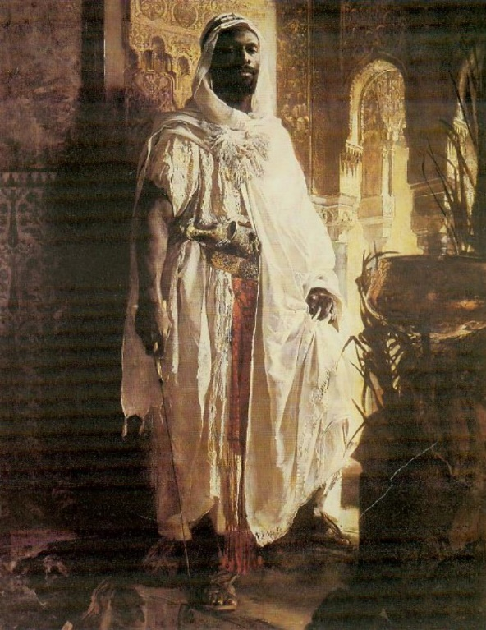**The Meaning of the Word, Hebrew**

**The term *Hebrew* means "to wander" or "to cross over."  It was first applied in scripture to the forefather of the Israylite nation, Abraham.**

**Genesis 14:13 - And there came one that had escaped, and told Abram the Hebrew; for he dwelt in the plain of Mamre the Amorite, brother of Eshcol, and brother of Aner: and these *were* confederate with Abram.**

**This term was only applied to the chosen seed of Abraham, the Israylite Nation.  No other people in scripture had this term applied to them.  Hebrew is *not* the nationality.  Our nationality is Israyl—hence we are Israylites.  We were mainly called Hebrews by foreigners.  It is a relevant word for our people today.  There is nothing wrong with applying the term *Hebrew Israylites* to the modern descendants of the Israylites.**

**Noah's sons and their intermixing with one another gave birth to our modern nations of today.**

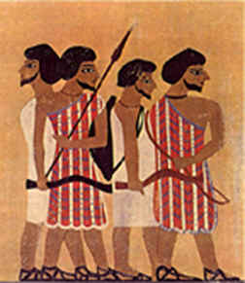

**Israyl in the Land of Egypt**

**The history of the Israylite nation began in Egypt, the land of Ham.  They entered Egypt 70 in number, and left with a populace of over two million people according to several estimations. Ancient Israyl spent 430 years in Egypt (Exodus 12:40).  For half that time they enjoyed good favor with the Egyptians.  But for the remainder of those years they were enslaved and horribly mistreated by them.**

**We will begin with the story of Jacob's second youngest son, Joseph, and his time in Egypt. Joseph was the eleventh of father Israyl's twelve sons.  Jacob had Joseph in his old age, and he was clearly his favorite son.  This caused Joseph's brothers to become jealous of him.**

**Images of Ancient Israylites taken from an Egyptian Tomb Painting**

**Genesis 37:5 - And Joseph dreamed a dream, and he told it his brethren: and they hated him yet the more.**

**v. 6 - And he said unto them, Hear, I pray you, this dream which I have dreamed:**

**v. 7 - For, behold, we *were* binding sheaves in the field, and, lo, my sheaf arose, and also stood upright; and, behold, your sheaves stood round about, and made obeisance to my sheaf.**

**v. 8 - And his brethren said to him, Shalt thou indeed reign over us? or shalt thou indeed have dominion over us?  And they hated him yet the more for his dreams, and for his words.**

**v. 11 - And his brethren envied him; but his father observed the saying.**

**Joseph's brothers plotted against him.  They wanted to physically kill him, but they decided to place him in a pit in hopes he would just die there instead.  Ultimately, their jealousy resulted in Joseph being sold to Ishmaylite (Arab) merchants, who in turn sold him as a slave to the Egyptians.  Remember, this story is key in understanding the prophecies of modern Israyl.**

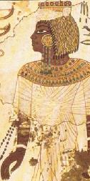**Genesis 37:20 - Come now therefore, and let us slay him, and cast him into some pit, and we will say, Some evil beast hath devoured him: and we shall see what will become of his dreams.**

**v. 21 - And Reuben heard it, and he delivered him out of their hands; and said, Let us not kill him.**

**v. 22 - And Reuben said unto them, Shed no blood, *but* cast him into this pit that *is* in the wilderness, and lay no hand upon him; that he might rid him out of their hands, to deliver him to his father again.**

**v. 23 - And it came to pass, when Joseph was come unto his brethren, that they stripped Joseph out of his coat, *his* coat of *many* colours that was on him;**

**v. 24 - And they took him, and cast him into a pit: and the pit was empty, *there* was no water in it.**

**v. 25 - And they sat down to eat bread: and they lifted up their eyes and looked, and, behold, a company of Ishmaelites came from Gilead with their camels bearing spicery and balm and myrrh, going to carry *it* down to Egypt.**

**v. 26 - And Judah said unto his brethren, What profit *is it* if we slay our brother, and conceal his blood?**

**v. 27 - Come, and let us sell him to the Ishmaylites, and let not our hand be upon him; for he is our brother *and* our flesh. And his brethren were content.**

**v. 28 - Then there passed by Midianites merchantmen; and they drew and lifted up**

**Joseph out of the pit, and sold Joseph to the Ishmaylites for twenty pieces of silver: and they brought Joseph into Egypt.**

**The modern Arabs trace their lineage to Abraham's first son, Ishmayl.  This is a very important point to remember:  It was the Abrabs who sold Israylites into slavery first in both ancient and recent times.**

**Renderings of Israylites being Enslaved by Ishmaylites (Arabs)**

|  |  |
| --- | --- |
|  |  |

**While in Egypt, Joseph worked as a slave and also spent 12 years in prison for being falsely accused of trying to rape his slave master's wife—ironically, an accusation that has plagued this nation to this very day.  While in prison, Joseph had the opportunity to interpret a very troubling dream that the ruling Pharaoh had; a dream in which nobody in Egypt knew the meaning.  And the interpretation saved Egypt from starving in a seven-year famine.**

**Genesis 41:15 - And Pharaoh said unto Joseph, I have dreamed a dream, and *there* is none that can interpret it: and I have heard say of thee, *that* thou canst understand a dream to interpret it.**

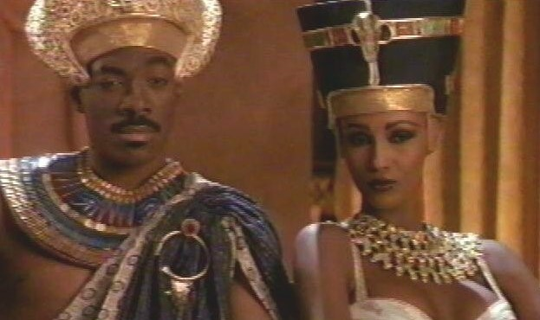**v. 16 - And Joseph answered Pharaoh, saying, *It is* not in me:**

**THE ALMIGHTY shall give Pharaoh an answer of peace.**

**v. 17 - And Pharaoh said unto Joseph, In my dream, behold, I stood upon the bank of the river:**

**v. 18 - And, behold, there came up out of the river seven kine, fatfleshed and wellfavoured; and they fed in a meadow:**

**v. 19 - And, behold, seven other kine came up after them, poor and very ill favoured and leanfleshed, such as I never saw in all the land of Egypt for badness:**

**v. 20 - And the lean and the ill favoured kine did eat up the first seven fat kine:**

**v. 21 - And when they had eaten them up, it could not be known that they had eaten them; but they *were* still ill favoured, as at the beginning.  So I awoke.**

**v. 22 - And I saw in my dream, and, behold, seven ears came up in one stalk, full and good:**

**v. 23 - And, behold, seven ears, withered, thin, *and* blasted with the east wind, sprung up after them.**

**7 Years of Plenty - 7 Years of Famine**

**Renderings of Pharoah's Dream**

|  |  |
| --- | --- |
|  |  |

**To show his gratitude to Joseph, Pharaoh made him Governor of all of Egypt.  Joseph was second in Command.  Only Pharaoh was above him in authority.**

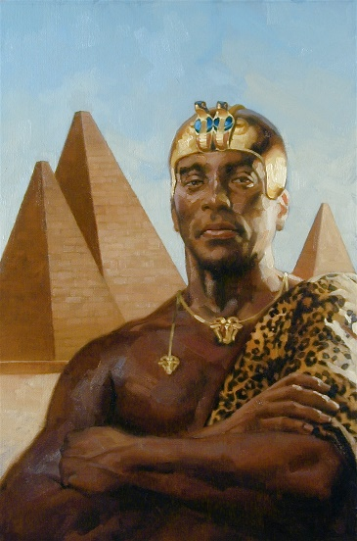**Genesis 41:39 - And Pharaoh said unto Joseph, Forasmuch as Yah hath shown thee all this, *there is* none so discreet and wise as thou *art*:**

**v. 40 - Thou shalt be over my house, and according unto thy word shall all my people be ruled: only in the throne will I be greater than thou.**

**v. 41 - And Pharaoh said unto Joseph, See, I have set thee over all the land of Egypt.**

**v. 42 - And Pharaoh took off his ring from his hand, and put it upon Joseph's hand, and arrayed him in vestures of fine linen, and put a gold chain about his neck;**

**v. 43 - And he made him to ride in the second chariot which he had; and they cried before him, Bow the knee: and he made him *ruler* over all the land of Egypt.**

**According to the interpretation of the dream, the famine was to last for seven years. There was to be seven years of good harvest followed by seven years of famine.  During the time of good harvest Joseph prepared Egypt by storing up grain that would be used during the famine.  This famine affected the whole world.  At this time, Joseph's family was living in the land of Canaan, which became the land of Israyl about five centuries later.  They too were affected by the famine.  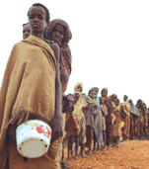**

**After Joseph's brothers sold him to the Ishmaylite, they reported to their father, Jacob (Israyl), that Joseph was dead—having been eaten by a wild beast.  So for all these years he thought his son was dead.  He sent ten of his remaining eleven sons to Egypt to buy corn.**

**Genesis 42:1 - Now when Jacob saw that there was corn in Egypt, Jacob said unto his sons, Why do ye look one upon another?**

**v. 2 - And he said, Behold, I have heard that there is corn in Egypt: get you down thither, and buy for us from thence; that we may live, and not die.**

**v. 3 - And Joseph's ten brethren went down to buy corn in Egypt.**

**When Joseph's ten brothers came into Egypt they were brought before him.  Joseph recognized his brothers, but they did *not* recognize him.**

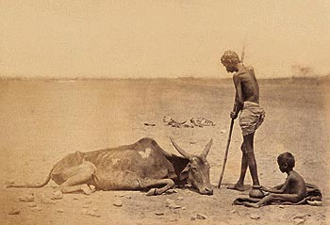

**v. 5 - And the sons of Israyl came to buy *corn* among those that came: for the famine**

**was in the land of Canaan.**

**v. 6 - And Joseph *was* the governor over the land, *and* he *it was* that sold to all the people of the land: and Joseph's brethren came, and bowed down themselves before him *with* their faces to the earth.**

**v. 7 - And Joseph saw his brethren, and he knew them, but made himself strange unto them, and spake roughly unto them; and he said unto them, Whence come ye? And they said, From the land of Canaan to buy food.**

**v. 8 - And Joseph knew his brethren, but they knew not him.**

**This story is very interesting.  Joseph has been living among the Egyptians for about 21 years at this time.  He stood before his brothers as second in command.  His brothers did *not* recognize him because he looked just like an Egyptian.  But remember, Joseph is a Hebrew Israylite.**

**As previously shown, the Egyptians were the sons of Ham.  Ancient images and scholarly testimonies prove they were a black-skinned nation. But if Joseph resembled an Ashkenazi Jew, then how could his brothers *not* recognize him amongst the black Egyptians?**

**A Comparison of Today's so-called**

**Children of Israyl (The Jews) to the Ancient Egyptians**

**Where's the Resemblance?**

|  |  |
| --- | --- |
| **Ashkenazi Jews** | **Ancient Egyptian Princess** |

**Years ago singer, Donnie Osmond, portrayed Joseph in a stage play titled, Joseph and the Amazing Technicolor Dreamcoat.**

**If Joseph and the Israylites looked like him (see image to the right), while the Egyptians looked like all of the images you've seen so far, how could he not be recognized by his brothers?**

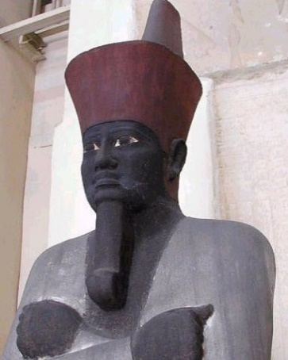**The Ancient Egyptians' Appearance According to Gentiles**

**The ancient Egyptians of Joseph's time were indeed what we know today as "black."  This is a fact attested to by many.**

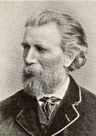**Gerald Massey, English writer and author of the book, *Egypt the Light of the World*, wrote, "The dignity is so ancient that the insignia of the Pharaoh evidently belonged to the time when Egyptians wore nothing but the girdle of the Negro" (p. 251).**

**Pharaoh Mentuhotep II**

**Gerald Massey**



**Sir Richard Francis Bacon**

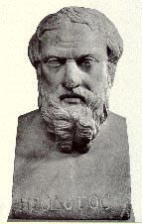**Sir Richard Francis Burton, a 19th century English explorer, writer, and linguist in 1883 wrote to Gerald Massey, "You are quite right about the 'AFRICAN' origin of the Egyptians.  I have 100 human skulls to prove it."**

**Herodotus**

**Scientist, R. T. Prittchett, states in his book, *The Natural History of Man*, "In their complex and many of the complexions and in physical peculiarities the Egyptians were an 'AFRICAN' race" (p. 124-125).**

**The ancient Greek historian, Herodotus, who visited Egypt in the 5th century B.C.E., saw the Egyptians face to face and described them as black-skinned with woolly hair.**

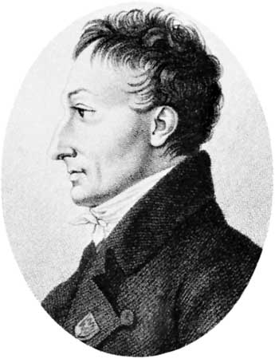**Anthropologist, Count Constatin de Volney (1727-1820), spoke about the Egyptians that produced the Pharaohs.  He later paid tribute to Herodotus' discovery when he said:**

**Count Constatin de Volney**

**“The ancient Egyptians were true Negroes of the same type as all native born Africans.  That being so, we can see how their blood, mixed for several centuries with that of the Romans and Greeks, must have lost the intensity of its original color, while retaining nonetheless the imprint of its original mold.  We can even state as a general principle that the face (referring to The Sphinx) is a kind of monument able, in many cases, to attest to or shed light on historical evidence on the origins of the people."**

**Volney also stated:**

**"What a subject for meditation.  Just think that the race of black men today, our slaves and the object of our scorn, is the very race to which we owe our arts, science, and even the use of our speech."**

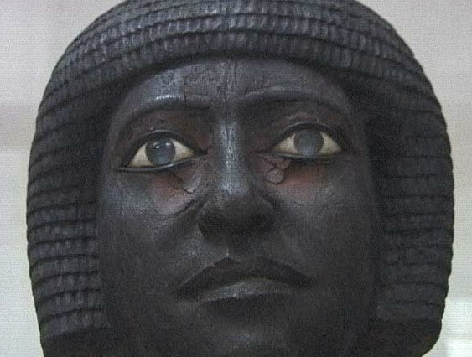**The testimony of the ancients, the scriptures, and many Egyptologists along with archaeology confirms that the Egyptians during ancient times were a "BLACK" people.  This is important to know.  As we continue, you will see that the scriptures on multiple occasions describe the ancient Hebrews as resembling the Egyptians in physical appearance.**

**Statue of an Ancient Egyptian Man**

**Hammites Mistake the Israylites for Their Own Kind**

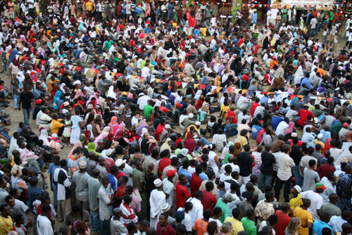**As we read on in scripture we discover something else that is interesting to note about the Israylites' stay in Egypt.  Genesis, chapters 49 and 50, describe the death of one of the Hebrew forefathers, Israyl (Jacob).  Our father, Israyl, died in the land of Egypt.  His son, Joseph, was still second in authority at the time of his death.  He was *not* buried in Egypt, but in Canaan, the land of promise.**

**Genesis 49:29 - And he charged them, and said unto them, I am to be gathered unto my people: bury me with my fathers in the cave that *is* in the field of Ephron the Hittite.**

**Father Israyl was transported from Egypt to Canaan in a great company of mourners.**

**Genesis 50:7 - And Joseph went up to bury his father: and with him went up all the servants of Pharaoh, the elders of his house, and all the elders of the land of Egypt,**

**v. 8 - And all the house of Joseph, and his brethren, and his father's house: only their little ones, and their flocks, and their herds, they left in the land of Goshen.**

**v. 9 - And there went up with him both chariots and horsemen: and it was a very great company.**

**v. 10 - And they came to the threshingfloor of Atad, which *is* beyond Jordan, and there they mourned with a great and very sore lamentation: and he made a mourning for his father seven days.**

**v. 11 - And when the inhabitants of the land, the Canaanites, saw the mourning in the floor of Atad, they said, This is a grievous mourning to the Egyptians: wherefore the name of it was called Abel mizraim, which *is* beyond Jordan.**

**Notice that this was a mixed multitude of Hebrews and Egyptians going to bury a Hebrew, and the Canaanites identified them both as Egyptians in verse 11.  Why?  Isn’t that interesting?**

**The Canaanites saw a great company of black-skinned people who all look like native (black) Egyptians.  It's only logical to assume that the Hebrews were mourning the hardest in the burial procession for our father, Jacob, and *this* is who the Canaanites saw.  When they describe this great mourning for Jacob, the Hebrew, they saw Israylites mourning the greatest, and they thought these Hebrews were Egyptians.**

**If the Canaanites were familiar with both Hebrews and Egyptians they would have acknowledged them both by saying, "This is a grievous mourning to the Egyptians AND Hebrews."  If the Hebrews did *not* resemble the Egyptians in physical appearance, without a doubt, white Hebrews would have stuck out like a sore thumb amongst the black Egyptians.  The Canaanites *never* identified the Hebrews separately from the Egyptians.**

**Images of Ancient Egyptians & Modern Israylites**

|  |
| --- |
|  |
|  |
|  |

|  |  |
| --- | --- |
| **Queen Tiye • Grandmother of King Tut** | **Michelle Obama • High School Photo** |

**The scripture goes on to say that the Canaanites named the place where they saw this great mourning for a Hebrew: Abel Mizraim, which means the “Mourning of the Egyptians.”**

**The Israylites' Exodus Out of Egypt**

**During the Israylite's 430-year tenure in Egypt, the most famous story recorded is the “EXODUS.”  Exodus is the second book of the bible and is derived from the Greek word, *éxodos*, which means “marching out, going out.”  The actual name of the book in Hebrew is *Shemoth* and it means, “Names.”**

**Many years after the death of Father Israyl and all of that generation that entered Egypt during the time that Joseph was viceroy, the Hebrews' population in Egypt grew tremendously. Because of this they were no longer looked upon as friendly neighbors.  The Egyptians now considered them hostile enemies and enslaved them as a result.**

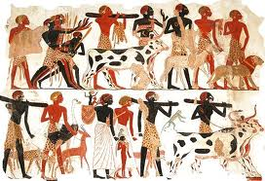

**Exodus 1:8 - Now there arose up a new king over Egypt, which knew not Joseph.**

**v. 9 - And he said unto his people, Behold, the people of the children of Israyl *are* more and mightier than we:**

**v. 10 - Come on, let us deal wisely with them; lest they multiply, and it come to pass, that, when there falleth out any war, they join also unto our enemies, and fight against us, and *so* get them up out of the land.**

**v. 11 - Therefore they did set over them taskmasters to afflict them with their burdens.  And they built for Pharaoh treasure cities, Pithom and Raamses.**

**v. 12 - But the more they afflicted them, the more they multiplied and grew.  And they were grieved because of the children of Israyl.**

**Because of the Hebrews' population growth, the Egyptians decided they would impose upon them their own form of birth control.  Pharaoh made a decree for all Hebrew baby boys to be killed at birth.**

**Exodus 1:22 - And Pharaoh charged all his people, saying, Every son that is born ye shall cast into the river, and every daughter ye shall save alive.**

**This brings us directly to the story of Moses.**

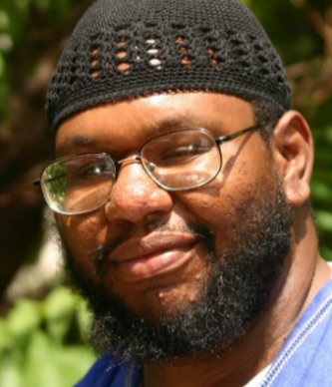

**About Obadiyah Ysrayl**

**[](https://www.facebook.com/obadiyah.ysrayl.9)Obadiyah Ysrayl is one of the founding members of**[**Israylite Heritage**](http://www.israyliteheritage.com)**(IH).  Girded with the mission to fulfill his Yah ordained duty of restoring the truth of the bible to the Hebrew Israylites and all other nations since 1996, he is heavily involved in the community.  Serving as a teacher for the IH family, Obadiyah presents weekly lessons via the Paltalk chat room,**[**Yah and Yahoshua are Real**](http://www.paltalk.com/g2/paltalk/991577755)**, on Saturday, the *true*Sabbath, followed by a Q&A session every Thursday.  On Sunday, he hosts the**[**Israylite Way**](http://www.blogtalkradio.com/israyliteheritage)**biweekly radio show on Blog Talk.  Visit the**[**Israylite Heritage website**](http://www.israyliteheritage.com)**for his full schedule.**

**He lectures and conducts immersions worldwide.**

**Most known for the documentaries,**[**The Curses of the Hebrew Israylites**](https://www.youtube.com/watch?v=M-tJZ9XQRKs&list=PLZ1aqRAd2jUCDcdF92eAIDVQmWx3hPzOg) **and** [**The Bible vs. Christianity**](https://www.youtube.com/watch?v=c1Rvj-qBths&list=PLZ1aqRAd2jUCDcdF92eAIDVQmWx3hPzOg)**, along with the video lesson series,**[**The Physical Appearance of Israyl**](https://www.youtube.com/watch?v=yPL8UExCF3s&list=PLZ1aqRAd2jUCDcdF92eAIDVQmWx3hPzOg)**, he is the driving force behind Israylite Heritage Productions and author of**[**Restoring the Forgotten Heritage to the Forgotten People: The Identity and Destiny of the Children of Israyl**](http://www.israyliteheritage.com/publications)**.  Mr. Ysrayl is the regent of the Israylite Heritage Research & Fellowship Center (**[**IHRFC**](http://www.israyliteheritage.com/ihrfc)**) in Chicago, IL, and the President and CEO of sister charity,**[**Israylite Heritage Feed My People**](http://www.ihfeedmypeople.org)**.**

**He welcomes you to connect with him on**[**Facebook**](https://www.facebook.com/obadiyah.ysrayl.9)**and join the IH**[**mailing list**](http://www.israyliteheritage.com/join-our-mailing-list)**to stay abreast of newly released productions and publications.  Schedule a lecture with Obadiyah**[**online**](http://www.israyliteheritage.com/schedule-a-lecture)**or by calling 844.SEEK.YAH | (844)733-5924.**